|  |
| --- |
|  |
| User Manual  Rotary Youth Driving Awareness (Admin) |
| **Creation date: 9/23/2017** |
|  |
|  |
|  |

This user manual is for the Rotary Youth Driving Awareness (RYDA) Quiz system. All the screenshots are captured using Google Chrome (Version 55). Compatibility test was done on Google Chrome, Internet Explorer (Edge) and Safari. Test result is satisfactory. Application can run on any version of the browser.

Table of Contents

1. Login 3

2. Quiz List 3

3. Create Quiz 4

4. Question List 4

5. Create Question and Answer 5

6. User List 6

7. Create User 6

8. Student List 7

9. Report 8

# Login

* Open web browser i.e Firefox, Chrome or Safari
* Type the web address <http://localhost:8080/RYDA/login.xhtml>
* Enter the credential to enter to the system. (Figure 1)
* Then user will see the Dashboard (Figure 2) where menu is listed.

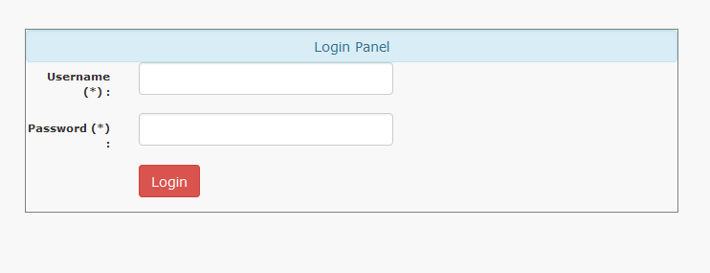

**Fig 1. Login Page**

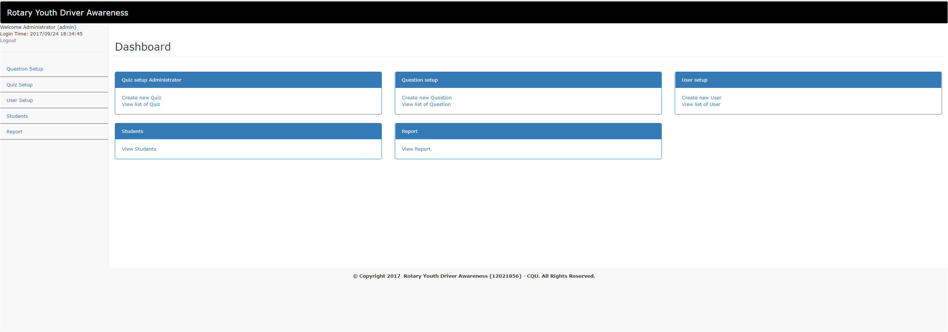

**Fig 2. Dashboard Menu**

# Quiz List

* Click on **Quiz Setup** on the left-hand side of the menu
* User will see the list of quiz (Figure 3)

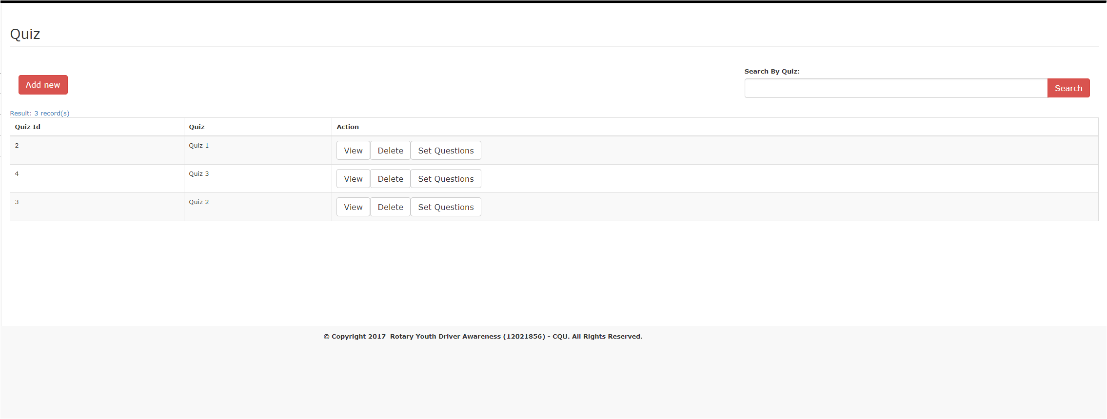

**Fig 3. Quiz List**

# Create Quiz

* Click on **Quiz Setup** on the left-hand side of the menu
* User will see the list of quiz
* Above list of quiz, there is “**Add Quiz**” button
* Click on the button
* User will be redirected to next page where user can enter the desired quiz name and save it. (Figure 4)

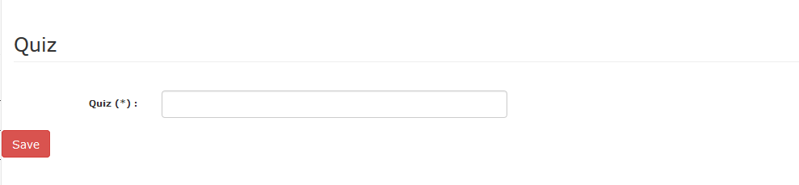

**Fig 4. Create Quiz**

# Question List

* Click on **Question Setup** on the left-hand side of the menu
* User will see the list of question (Figure 5)

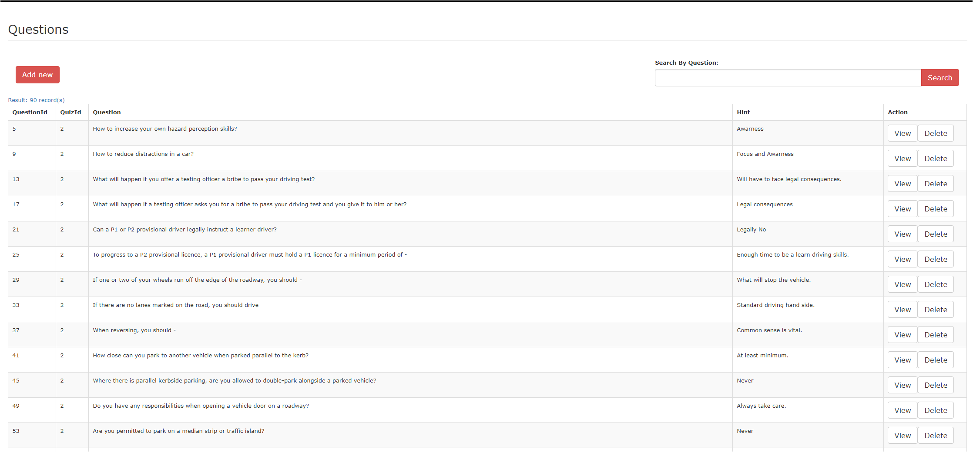

**Fig 5. Question List**

# Create Question and Answer

* Click on **Question Setup** on the left-hand side of the menu
* User will see the list of question
* Above list of question, there is “**Add Question**” button
* Click on the button
* User will be redirected to next page where user can select the quiz name, enter the desired Question, provide hint to the question and save it. (Figure 6)
* Setup answer by entering the answer one by one and saving.
* For correct answer, tick the “**Is Correct**” box (Figure 6)

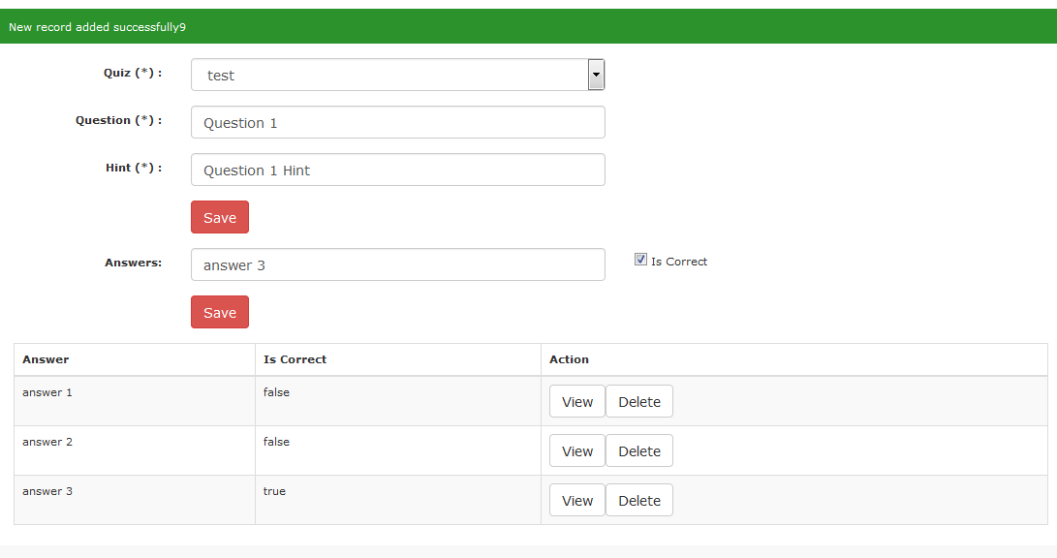

**Fig 6. Question and Answer setup**

# User List

* Click on **User Setup** on the left-hand side of the menu
* User will see the list of user (Figure 7)

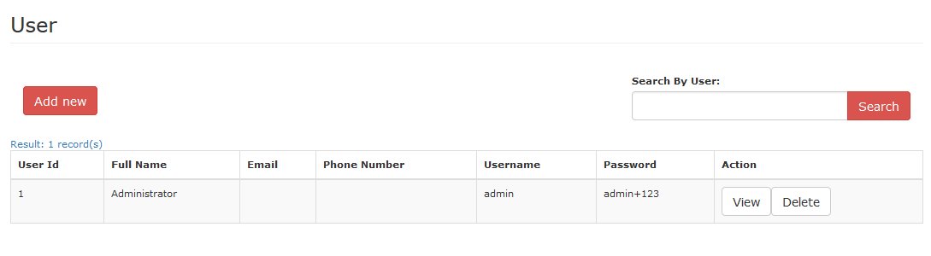

**Fig 44. User’s List**

# Create User

* Click on **User Setup** on the left-hand side of the menu
* User will see the list of User
* Above list of user, there is “**Add User**” button
* Click on the button
* User will be redirected to next page where admin can enter details of the user and click “**Save**”. (Figure 4)

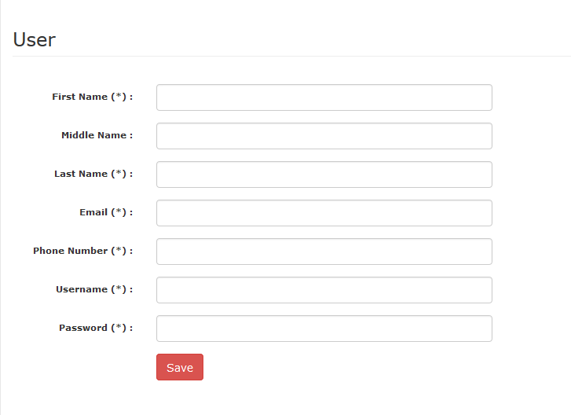

**Fig 7. Create User**

# Student List

* Click on **Students** on the left-hand side of the menu
* User will see the list of students who attempted the quiz

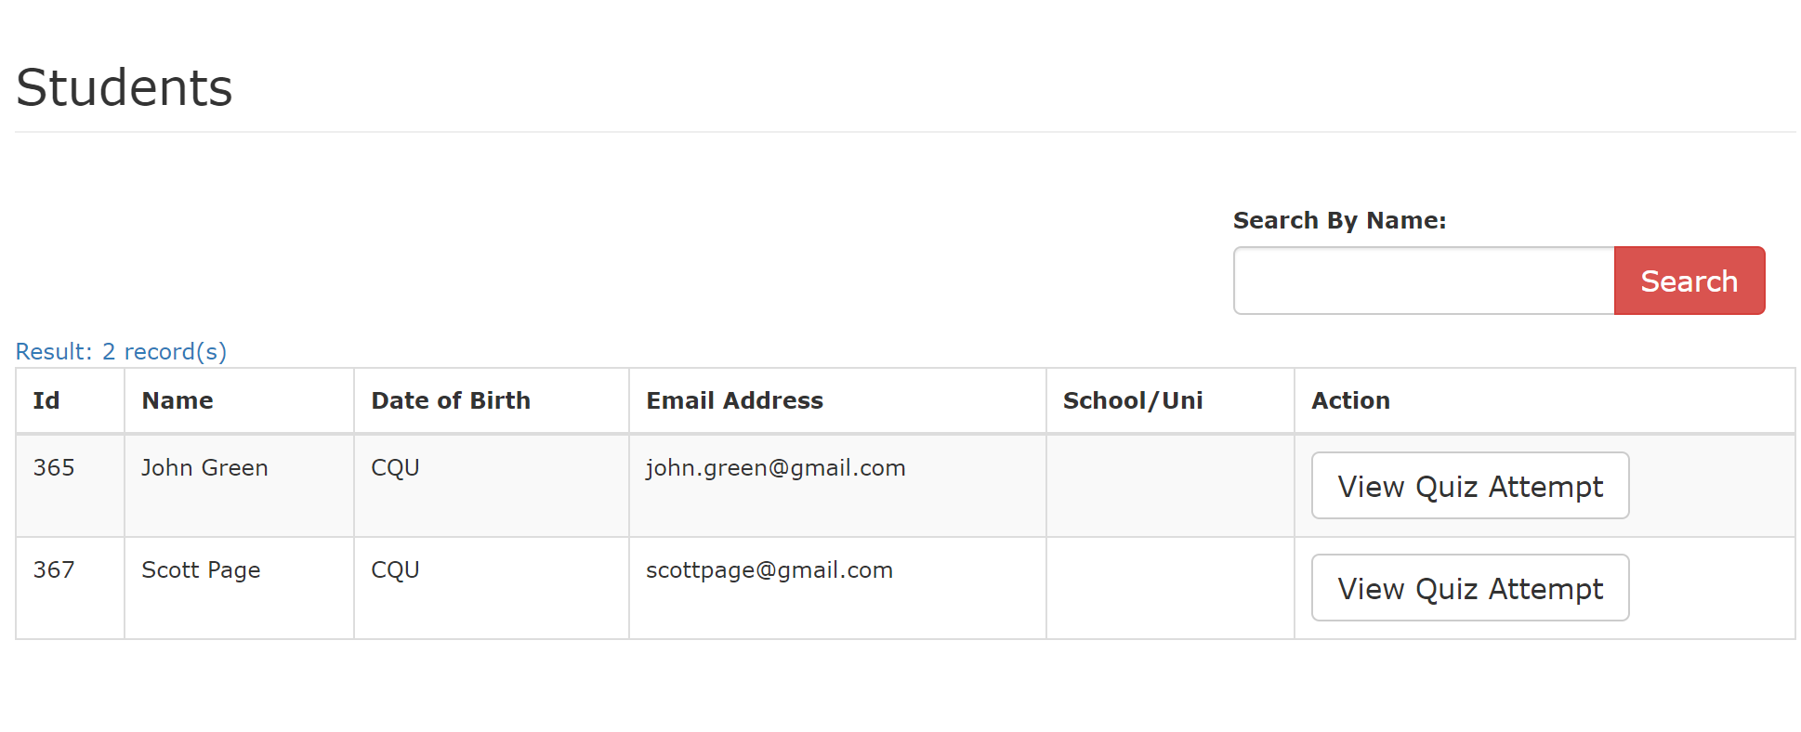

**Fig 7. Student List**

# Report

* Click on **Report** on the left-hand side of the menu
* User will see the list of Quizzes and their student attempts
* The user can view the list of students who attempted the quiz by clicking on the **link on No of attempts column**

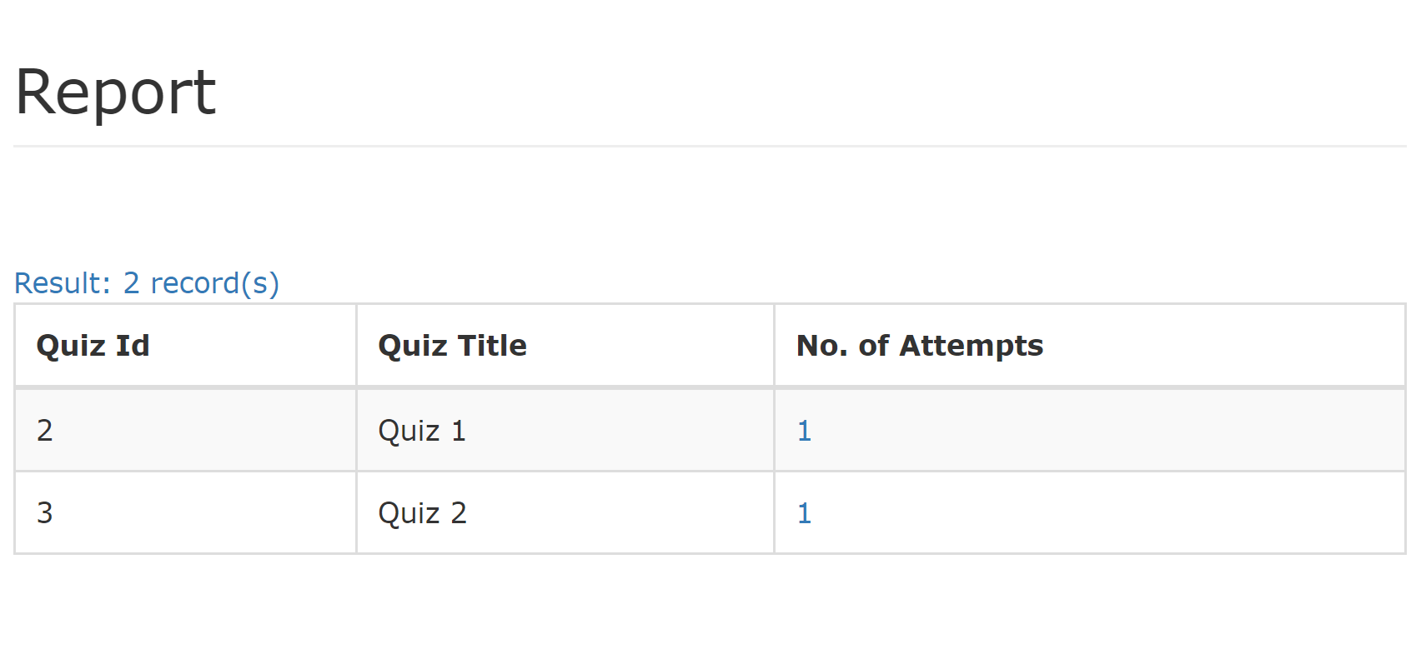

**Fig 7. Report**